1. Meng found the ecosystem should be “tidal_fresh_marsh”, instead of “marsh” on the original master datasheet.

2. Above- and belowground biomass data was from text (page 231)

The aboveground biomass data on the original datasheet was calculated from the min and max of the biomass during the growing season. However, Meng and Pat confirmed that we should use the peak (max) biomass instead. Therefore, in the updated data sheet, we use 1039 g/m2 for aboveground plant and 782 g/m2 for belowground biomass. Details can be found in the below text.

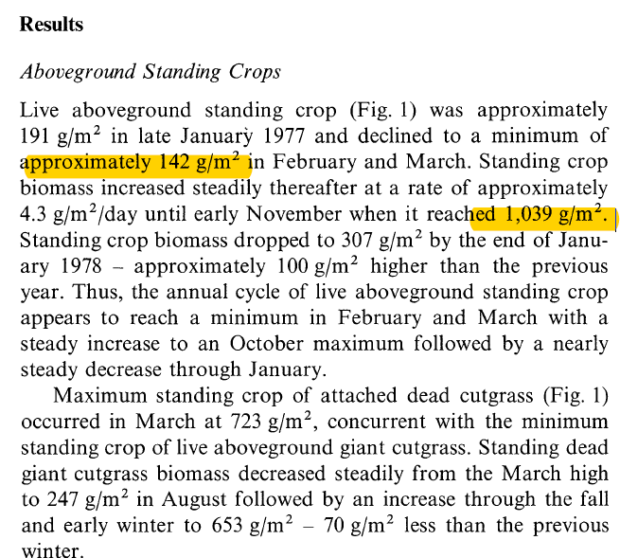

The belowground biomass was calculated from the min and max of the biomass

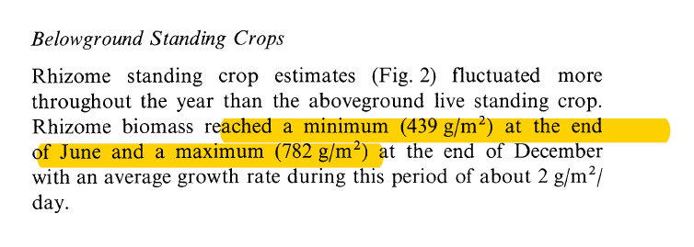

3. Above- and belowground biomass rate data was from Table 2 (page 232)

